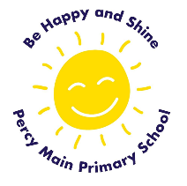 CUSP History Curriculum Overview at Percy Main Primary School

The study of the past - learning about people, places, events and changes
CUSP History draws upon prior learning, wherever the content is taught. For example, in the EYFS, pupils may learn about the past and present through daily activities, exploring through change, and understanding more about the lives of others through books and visitors as well as their own experiences. These experiences are drawn upon and used to position new learning in KS1.
The structure is built around the principles of advancing cumulative knowledge, chronology, change through cause and consequence, as well as making connections within and throughout periods of time studied.
CUSP History is planned so that the retention of knowledge is much more than just ‘in the moment knowledge’. The cumulative nature of the curriculum is made memorable by the implementation of Bjork’s desirable difficulties, including retrieval and spaced retrieval practice, word building and deliberate practice tasks. This powerful interrelationship between structure and research-led practice is designed to increase substantive knowledge and accelerate learning within and between study modules. That means the foundational knowledge of the curriculum is positioned to ease the load on the working memory: new content is connected to prior learning. The effect of this cumulative opportunities for children to associate and connect with significant periods of time, people, places and events.
CUSP History strategically incorporates a range of modules that revisit, elaborate and sophisticate key concepts, events, people and places.
A guiding principle of CUSP History is that pupils become ‘more expert’ with each study and grow an ever broadening and coherent mental timeline. This guards against superficial, disconnected and fragmented understanding of the past. Specific and associated historical vocabulary is planned sequentially and cumulatively from Year 1 to Year 6. High frequency, multiple meaning words (Tier 2) are taught alongside and help make sense of subject specific words (Tier 3). Each learning module in history has a vocabulary module with teacher guidance, tasks and resources.
CUSP fulfils and goes well beyond the expectations of the National Curriculum as we believe there is no ceiling to what pupils can learn if the architecture and practice is founded in evidence-led principles.
Substantive knowledge - this is the subject knowledge and explicit vocabulary used about the past. Common misconceptions are explicitly revealed as non-examples and positioned against known and accurate content. Misconceptions are challenged carefully and in the context of the substantive and disciplinary knowledge.
In CUSP History, it is recommended that misconceptions are not introduced too early, as pupils need to construct a mental model in which to position new knowledge.
CUSP have defined substantive concepts that are the suggested vehicle to connect the substantive knowledge. These are defined at the start of every study in the Big Idea.
Big Ideas
Big Ideas – Substantive Concepts
Community | Knowledge | Invasion | Civilisation | Power | Democracy
This gives us a focus on a large group of people living in a place.  I  This can be within a large area, such as the community of people during the Great Fire of London or the Windrush Generation.  It can also the evolving communities of the people in Palaeolithic, Mesolithic and Neolithic times.  I  Community can also be the people affected in World Wars | This gives a focus on the difference knowledge makes to people.  |  The migration of people and their knowledge of technology, such as smelting bronze, led to a change in the way people lived their lives.  Knowledge brings about change.  I  This can be seen through the emergence of great civilisations, such as the Ancient Egyptians.  I  It can also be the rise of knowledge and invention, such as the Maya or Ancient Greeks | Taking over another country or region with an armed force.  |  Hitler’s iniquitous beliefs led him to invade Poland and France.  Invasion is a substantive concept throughout history.  |  It can mean a small-scale forceable take-over of a village or town, or in the larger scale of a city-state or country. | A large group of people who follow similar laws, religion and rules.  |  Larger than a community.  |  Great civilisations have cities, architecture, laws, culture and art.  |  Ancient Egyptians, Greeks and Maya were great civilisations.  |  They advanced their society through knowledge and power | The power to advance technology, architecture and the arts. or the power over people and places.  |  Power to build The Parthenon, great theatres and the Lighthouse at Alexandria.  |  Power struggle: Athens vs Sparta or Anglo-Saxons and Vikings.  |  Kings, queens and leaders used power to achieve their goals, such as Queen Victoria and her desire to rule an Empire.  |  Alexander the Great unified power in Ancient Greece.  |  War with the Persians | A form of government voted for by the people.  |  Democracy has many forms through time.  |  In Ancient Greece, certain people in Athens could vote, but it wasn’t a true democracy.  |  Democracy hasn’t always been equal.  |  Democracy today is typically represented by a government who are voted for by the majority of people in that country.  |  The opposite to democracy is dictatorship or tyrannical leadership

Disciplinary knowledge – this is the use of that knowledge and how children construct understanding through historical claims, arguments and accounts. CUSP call it ‘Working Historically.’ The features of thinking historically may involve significance, evidence, continuity and change, cause and consequence, historical perspective and contextual interpretation. Content infused and adapted from HA – Teaching History 179 and 180, 2020.
Historical Enquiry
SUGGESTED DISCIPLINARY KNOWLEDGE – THINKING AS A HISTORIAN
Historical enquiry | Structured and relevant enquiry that sets pupils on a historical quest. Each knowledge note has a learning question that gives the pupils the opportunity to attempt and apply their understanding of the substantive knowledge (what pupils KNOW) in a disciplinary way (what pupils DO). These cumulate towards a more expert understanding of the big idea
Chronology | Cause & consequence | Change & continuity | Similarity & difference | Evidence | Significance
The science of time  |  How events and significant people are placed in time.  |  Chronological order means to place people or events in a sequence which represents the passing of time.  |  Use time related words, such as before, during and after.  |  BC = Before the birth of Christ. Also known as BCE = before the common era.  |  AD = Anno Domini (the number of years after the death of Christ).  |  Also known as CE = common era.  |  There is no year 0, only 1 BC and AD 1. | The reason and result of the things that happened in history  |  Causation is about why events occurred and situations happened.  |  How ideas connect and interrelate.  |  Grouping causes into categories, such as personal belief, military action, economic drivers or deliberate acts.  |  Causation is best used to think historically when the narrative of the study is secure and the big ideas are coherent, such as significant people, places, events and time.  Consequence is the result of the cause. | How key people, places and events changed or stayed the same over time  |  How much really changed over and across time?  |  What kind of change was occurring? Was it social, military, economic?  |  Pace and process: how quickly did things change? Lee, P. (2005) recommends stopping pupils thinking of historical change like a volcano - instant and destructive.  Continuity  |  Latin: continuitatem = a connected series. What remained the same?  |  What factors were the same? Trade? Ideas of race? | Similarity  |  Compare similarities at the same time - what stayed the same and why?  For example, you could compare Athens and Sparta at the same time.  Difference  |  Compare difference at the same time – what was different between people and places – why was that?  For example, you could examine the beliefs of Nazi Germany and the allies. | How we know about the past  |  A source presents a viewpoint, position angle or bias from the time it was created.  |  Unwrapping a source tells pupils more about the attitudes, beliefs and culture of that time.  Relics can be used and are sources  |  objects, artefacts and architecture don’t carry a conscious testimony (Adapted from Ashby, 2017).  Primary sources  |  original documents, images or artefacts that provide a firsthand testimony to help inform the related study.  Secondary sources  |  books and articles about a study that may not have been created at the time | Why people, events and ideas are important in our studies  |  The choice to study certain people and events because of their importance over time.  Latin: significare  |  to make signs or point out.  Significant people and events are chosen by others to tell a historical narrative.  |  Why have they been chosen? What is significantly good or bad about these people and events?  Also consider ‘silences’  |  (the not told history) as an opposite and equal to significance. (Trouillot and HA 181,2020)  |  What stories were not told or are now emerging, such as the Windrush generation.

3. Historical analysis is developed through selecting, organising and integrating knowledge through reasoning and inference making in response to our structured questions and challenges. We call this ‘Thinking historically’.

4. Substantive concepts, such as invasion and civilisation are taught through explicit vocabulary instruction as well as through the direct content and context of the study

LONG-TERM SEQUENCE FOR HISTORY – EYFS to KS1
Specific Area of Learning  Understanding the World | Past and Present | Key Vocabulary to be  developed in EYFS | Examples of how this is  achieved in Nursery | Examples of how this is achieved in  Reception | History KS1
 | - Talk about the lives of the people around them and their roles in society.  - Know some similarities and differences between things in the past and now, drawing on their experiences and what has been read in class.  - Understand the past through settings, characters and events encountered in books read in class and storytelling. | - History  - Historian  - After  - Before  - New  - Old  - Young  - Now  - Past  - Present  - Time  - Celebration  - Tradition  - Culture  - Belief | The children in Nursery will:  - Know about personal history – birthdays, celebrations.  - Celebrate cultural diversity of children in the class.  - Celebrate traditional festivals and celebrations.  - Through interactions talking about what they did yesterday, last week, last year.  - Begin to question what makes them unique and can describe what they feel is special about them and others  - Show interest in different occupations.  - Explore how things work.  - Show interest in different occupations  - Continue developing positive attitudes about the differences between people.  - Know that there are different countries in the world and talk about the differences they have experienced or seen in photos. | The children in Reception will:  - Understand personal history: how they celebrate Christmas, new year, family celebrations such as birthdays – throughout the year.  - Learn about the family traditions of children in class from different cultural backgrounds.  - Celebrate significant events such as Remembrance Day, Black History week – Rosa Parks, Bonfire Night – Guy Fawkes.  - Comment on familiar images from the past, compare them to current images.  - Be able to talk about differences between now and the past, using knowledge gained from discussion, books, internet and investigation in class. | - Changes within living memory. Where appropriate, these should be used to reveal aspects of change in national life.
 |  |  |  |  | - Events beyond living memory that are significant nationally or globally.
People, Culture and Communities

- Describe their immediate environment using knowledge from observation,
discussion, stories, non-fiction texts and maps.
- Know some similarities and differences between different religious and cultural communities in this country, drawing on their experiences and what has been read in class.
- Explain some similarities and differences between life in this country and life in other countries, drawing on knowledge from stories, non-fiction texts and (when appropriate) maps.

Long Term Sequence for History
 | Autumn | Spring | Summer
Year 1 | Changes within living memory | The lives of significant people (Mary Anning and David Attenborough) | More lives of significant people  (Neil Armstrong, Mae Jemison, Bernard Harris Jr., Tim Peake)
Year 2 | Events beyond living memory (Great Fire of London) | Significant historical events, people, places in our locality | Significant historical events, people, places in our locality  Revisit – Events beyond living memory
Year 3 | Stone Age – Iron Age | Stone Age – Iron Age  Rome and the impact on Britain | Rome and the impact on Britain
Year 4 | Britain’s settlement by Anglo-Saxons and Scots  Viking and Anglo-Saxon struggle for the Kingdom of England to the time of  Edward the Confessor | Viking and Anglo-Saxon struggle for the Kingdom of England to the time of Edward the Confessor  Ancient civilisation - Egypt or Shang Dynasty | Ancient civilisation - Egypt or Shang Dynasty
Year 5 | Ancient Greece | Ancient Greece  Comparison study – Maya or Benin and Anglo-Saxons | Comparison study – Maya or Benin and Anglo-Saxons
Year 6 | Local History Study - how did conflict change our locality in World War 2? | Windrush generation | 5 significant monarchs

Vocabulary progression Tier 2 vocabulary Tier 3 vocabulary
 | Theme | Theme |  | Theme | Theme | Theme
EYFS | Past and Present | People, Culture and Communities
Reception | After, Before, New, Old, Now.  Past, present, history, historian. | Celebrate, Together, Different, Same  Tradition, Culture, Belief
Yr1 | Changes within living memory | The lives of significant people | Yr 2 | Events beyond living memory | Significant historical  events, people and places in their locality.
 | Toddler, timeline, present, compare, memory Community, tills,  supermarket, customer, bakery. | Legacy, inspire, revealed, explore, similar  Fossil, documentary, significant, naturalist,  expedition, orbit, racism, astronaut. |  | Bustling, raged, extinguished, merchant, engulfed.  Flammable, devoured, possessions, ineffective, doused | Jockey, chronology, memorial, devastated, converted, founded Monarch, common, code, coat of arms, racecourse, airfield
Yr3 | Changes in Britain from the Stone Age to the Iron age | The Roman Empire and its impact on Britain | Yr 4 | Britain’s Settlement by the Anglo-Saxons and Scots | The Viking and Anglo- Saxon struggles. | Ancient Egypt
 | Ancient, community, dense, extinct, roaming, prehistory.  Domesticated, arid, gatherer, nomad, reared, submerged. | Previously, conquered, rebellion, luxurious, culture, settlement.  Amphitheatre, emperor, aqueducts, invasion, barbarian, forum. |  | Abandoned, defenceless, dominant, missionary, Pagan, reliant  Heptarchy, laden, sporadic, vanquish,  viewpoint, migration | Contested, exile, descendant, heir, plunder, truce.  Decimated, incursion, ransack, severed, martyr, marauding | Colossal, stability, society, civilisation, irrigation, mysteriously. Funerary, hieroglyphs, artefact, pillaged, obelisk, pharaoh
Yr5 | Ancient Greece | The Mayan Civilisation | Y6 | How did conflict change our local area in WW2? | A chronological study:  Windrush society | Monarchs
 | Democracy, honour, phenomenal, deteriorated, armoured, oppressive  City-state, tyrant, sanctuary, tactical, valiantly, unified | Population, famine, descendant, declining, citizen, native Deforestation, codex, sacrifice, astronomy, warrior, polytheistic |  | altitude boisterous cemetery penetrate  strategic  airbase Axis  Bombardment Incendiary  Memorial segregation | Intolerance, immigrate, prejudice, colony, emigrate, discrimination Racism, segregation, diversity, disembarked, demolished, iniquitous

Talking like a Historian
Spoken Language in the National Curriculum
Pupils should learn to justify ideas with reasons; ask questions to check understanding; develop vocabulary and build knowledge; negotiate; evaluate and build on the ideas of others; and select the appropriate register for effective communication. They should be taught to give well-structured descriptions and explanations and develop their understanding through speculating, hypothesising and exploring ideas. This will enable them to clarify their thinking as well as organise their ideas for writing.
In Key Stage 1:
Pupils should develop an awareness of the past, using common words and phrases relating to the passing of time.
They should use a wide vocabulary of everyday historical terms.
They should ask and answer questions, choosing and using parts of stories and other
sources to show that they know and understand key features of events
In Key Stage 2:
Pupils should regularly address and sometimes devise historically valid questions about change, cause, similarity and difference, and significance.
They should construct informed responses that involve thoughtful selection and organisation of relevant historical information.
Talk like a Historian Sentence Stems
- … and … are similar because...
- … and … are different because...
- … has...happened/ changed because …
- ... and … are different because...and...
- I believe it is the same, due to....
- It is significant because...
- This source is reliable because...
- How do the sources suggest...?
- The most significant reason was...
- I believe the most important factor was...
- This is similar to...
- During this time, .... remained the same / different, therefore....
- In my opinion, ...has stayed the same. I know this because...
- The impact of this event on us now is…
- Based on..., I conclude that...
- The text stated..., from this we can infer that...
- There is evidence to suggest that...
- The most significant effect of... was...
- A further key event was...
- This demonstrates continuity because....
- To some extent, the event of... caused...
- It is important to understand how concepts/ ideas change over time because …

Reading as a Historian
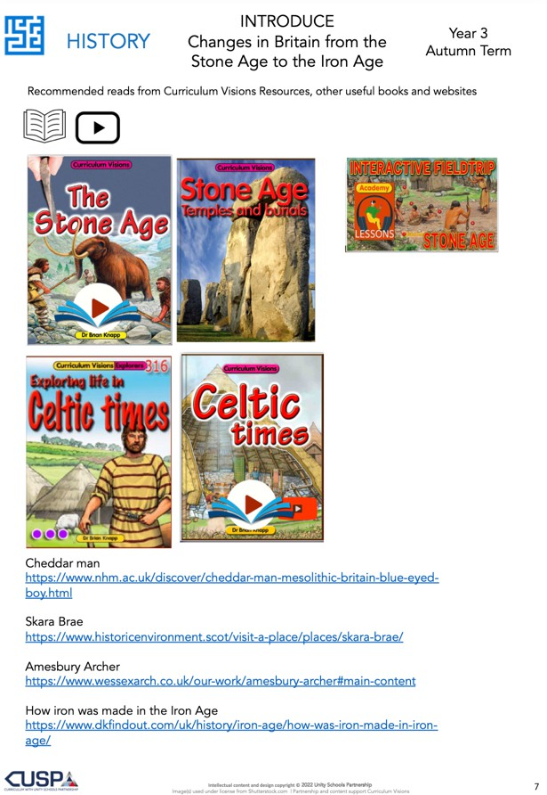
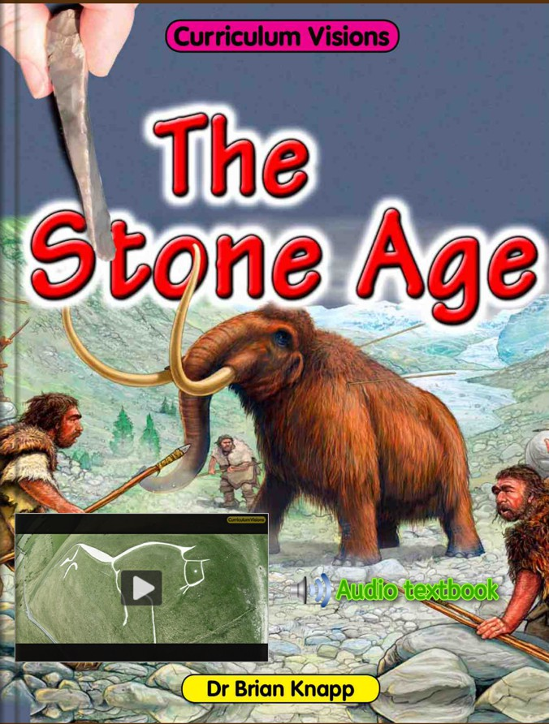
We subscribe to Curriculum Visions to support high-quality non-fiction texts that can also be accessed at home.

