
Percy Main Primary School
Special Educational Needs and / or Disabilities
Information Report.
Percy Main Primary School is committed to providing an inclusive and supportive environment where all students, regardless of their abilities or disabilities, can thrive and reach their full potential.
We support pupils with special educational needs and disabilities guided by the local offer.
We consult with pupils and their families by:
● Having regular meetings with children and their families.
● Day to day discussions on anything new that has arisen.
● Introducing them to outside agencies they may not have heard about.
● Letting them know what is available for them and their children.

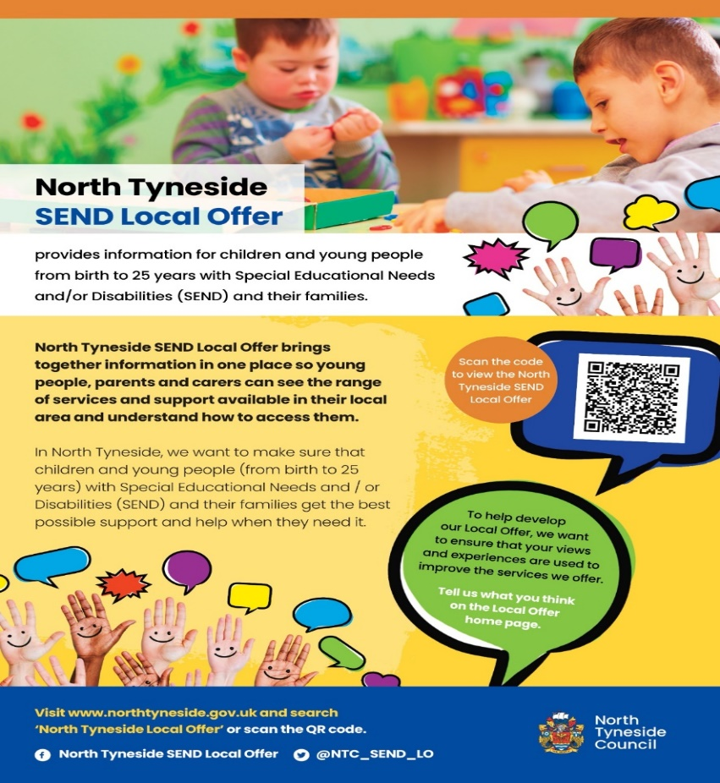
Percy Main Primary will endeavour to use its resources to provide appropriate support to children with special educational needs, thus enabling all children to obtain maximum benefit from the full school curriculum. Children with additional needs are likely to fall into the following categories:
● Those with learning difficulties.
● Those with visual or auditory impairment.
● Those with a physical disability.
● Those with social, emotional or mental health difficulties.

Children will be identified as having special educational needs if:
They are unable to
● Satisfactorily access the National Curriculum and/or
● Make satisfactory progress through the National Curriculum without additional teaching or
support different to that normally provided.
Local offer website: https://my.northtyneside.gov.uk/category/1243/local-offer-special-educational-needs-and-disabilities-send

Support and Provision:
Our school offers a range of support and provision in line with the Local Offer, including:

- Tailored teaching and learning strategies to accommodate diverse needs, including those related to medical conditions.
- Individualised SEND plans to address specific needs, including medical requirements.
- Access to specialist resources, equipment, and facilities to support students with medical difficulties.
- Staff members able to undertake training to provide assistance and to support in managing medical conditions.
- Collaboration with healthcare professionals and external agencies to ensure the holistic needs of students with medical difficulties are met.

Who are the best people to talk to in this school about my child’s difficulties with learning/Special Educational Needs or disability (SEND)?
If you have any concerns about your child’s learning or any area of Special Educational Needs
then the following people can be approached to discuss your concerns.
- Class Teachers - the class teacher would be your first point of contact. The teacher will listen to your concerns, discuss how your child is doing in the class and arrange a time to discuss your concerns further with the schools SENDCo.
- Special Educational Needs and Disability Co-ordinator (SENDCo) – Mrs Michele Mohun, who can co-ordinate additional support/provision within school and refer to outside agencies if required to obtain further support for your child.
- Head Teacher – Mrs Kathryn Thompson, who is responsible for:
The day-to-day management of all aspects of the school, including the support for children with SEND.
The Headteacher will give responsibility to the SENDCo for ensuring effective provision for children identified with SEND but is still ultimately responsible for ensuring that your child’s needs are fully met.
The Headteacher must make sure that the Governing body is kept up to date about issues relating to SEND.
- SEND Governor – Miss Carla Hemmans, responsible for: Making sure that the necessary support is given to any child who attends the school who has SEND.
Making sure that effective policy is in place and carried out in practise to ensure your child receives the best possible provision while in the care of Percy Main Primary to ensure their needs are fully met.
All of these people have your child’s needs as their main priority and will do everything they can to ensure your child’s needs are met and any concerns you have are addressed and looked into with speed and accuracy. They will also ensure you are:
● Involved in supporting your child’s learning at every point
● Kept involved about the support your child is getting
● Involved in reviewing how they are doing and planning future support
As a school we will endeavour to share any concerns around learning with parents by;
- Discussing concerns teaching and other staff may have.
- Sharing any discussions or concerns raised by the children or young people themselves.
- Informing you about the outcomes of initial checklists.
- Keeping you updated on progress made through consultation evenings (parent’s nights) and annual reports.

What support do we have for you as a parent of a child with SEND?
Percy Main Primary prides itself on having an open door policy. This means our staff are available to talk to you about any issues, needs or questions you may have at any time. If they cannot do this immediately then they will arrange a time which is convenient to both you and to them as soon as possible.
We will let families know about any concerns about a pupil’s learning by:
● Daily chats with teachers before and after school
● Meetings with the SENDCo
● School reports
● Discussions over the phone
● Formal meetings involving other agencies

What are the different types of support available for children with SEND in Percy Main Primary?
Class teacher input via excellent targeted classroom teaching also known as Quality First
Teaching. For your child this would mean:
● That the teacher has the highest possible expectations for your child and all pupils in their
class.
● That all teaching is based on building on what your child already knows, can do and can
understand.
● Different ways of teaching are in place so that your child is fully involved in learning in
class. This may involve things like using more practical learning.
● Specific strategies (which may be suggested by the SENDCo or outside staff) may be in
place to support your child to learn.
● Your child’s teacher will have carefully checked on your child’s progress and will have
decided that your child has gaps in their understanding/learning and needs some extra
support to help them make the best possible progress.
All children in school should be getting this as a part of excellent classroom practice when needed.

Specific group work within a smaller group of children. This group, often called Intervention
groups by schools, may be:
● Run in the classroom or outside.
● Run by a teacher or most often a Teaching Assistant who has had training to run these
groups.

It may be that your child needs further support and staff will draw up a SEND plan with specific targets for your child or young person which will be reviewed regularly. Your input and the voice of the child are integral in helping implement these SEND plans. Within each SEND plan there is a pupil profile page which helps support your child achieve their targets by communicating their needs/wants/likes and helps outline how best to support them to access their learning.

SEND code of Practice (June 2014) stage of support - SCHOOL SUPPORT means that your
child has been identified by the class teacher as needing some extra support in school.
For your child this would mean:
● He/ She will engage in group sessions with specific targets to help him/her to make more
progress.
● A Learning Support Assistant/teacher will run these small group sessions using the
teacher’s plan or the intervention plan.
This type of support is available for any child who has specific gaps in their understanding of a
subject/area of learning.

SEND code of Practice (June 2014) stage of support - SEND SUPPORT means that your child
has been identified by the class teacher/SENDCO as needing some extra specialist support in school from a professional outside the school. This may be from:
● Local Authority central services such as the Sensory Service (for students with a hearing or
visual need)
● Outside agencies such as the Speech and Language therapy (SALT) Service, the Dyslexia
Referral Team (DRT), the Language and Communication Team (LCT) or the Occupational
Therapy Team (OT)
For your child this would mean:
● Your child will have been identified by the class teacher/ SENDCo (or you will have raised
your worries) as needing more specialist input instead of or in addition to quality first
teaching and intervention groups.
● You will be asked to come to a meeting to discuss your child’s progress and help plan
possible ways forward.
● You may be asked to give your permission for the school to refer your child to a specialist
professional e.g. a Speech and Language Therapist, Educational Psychologist or Dyslexia
Referral Team specialist. This will help the school and you understand your child’s
particular needs better and be able to support them better in school.
● The specialist professional will work with your child to understand their needs and make
recommendations, which may include:
- Making changes to the way your child is supported in class e.g. some individual
support or changing some aspects of teaching to support them better
- Support to set better targets which will include their specific expertise
- A group run by school staff under the guidance of the outside professional e.g. a
social skills group
- A group or individual work with an outside professional.
● The school may suggest that your child needs some degree of individual support in school.
They will tell you how the support will be used and what strategies will be put in place.
This type of support is available for children with specific barriers to learning that cannot be
overcome through Quality First Teaching and intervention groups.

SEND code of Practice (June 2014) stage of support – SPECIFIED INDIVIDUAL SUPPORT
This is usually provided via an Education, Health and Care Plan (EHCP).
This means your child will have been identified by the class teacher/SENDCo as needing a particularly high level of individual or small group teaching. Usually, your child will also need specialist support in school from a professional outside the school. This may be from:
● Local Authority central services such as the Sensory Service (for students with a hearing or
visual need)
● Outside agencies such as the Speech and Language Therapy (SALT) Service, the
Dyslexia referral Team, the Language and communication Team or the Occupational
Therapy Team
For your child this would mean:
● The school (or you) can request that the Local Authority carry out a statutory assessment
of your child’s needs, Education, Health and Care Needs Assessment (EHCNA). This is a legal process which sets out the amount of support that will be provided for your child.
● After the school have sent in the request to the Local Authority (with a lot of information
about your child, including some from you), they will decide whether they think your child’s
needs (as described in the paperwork provided), seem complex enough to need a statutory
assessment. If this is the case, they will ask you and all professionals involved with your
child to write a report outlining your child’s needs. Parent views and the views of the child or young person are also part of the process. If they do not think your child needs this,
they will ask the school to continue with the support at SEND Support.
● After the reports have all been sent in, the Local Authority will decide if your child’s needs
are severe and if they need more support in school to make good progress. If this is the
case, they will write an EHC Plan. If this is not the case, they will ask the school to continue
with the support at SEND Support and also set up a meeting in school to ensure a plan is
in place to ensure your child makes as much progress as possible.
● EHC Plan will outline the desired outcomes from the support which is being put in place. It
will have long and short term goals for your child.
● This may mean that an additional adult may be used to support your child with whole class
learning, run individual programmes or run small groups including your child.
This type of support is available for children whose learning needs are:
● Severe, complex and/or lifelong
● Need specialist individual support in order to make progress in their learning

The other people / agencies and teams providing services to children with a special
educational need / disability in school include:
      - Educational Psychology Service
      - Language and Communication Team
      - Speech and Language Team
      - Occupational Therapy Service
      - Dyslexia / Dyscalculia Referral Team
      - Disability Team
      - Child and Adolescent Mental Health Service (CAMHS)
      - Early Help Assessment Team
      - Silverdale Outreach support.
      - Health -School Nurse, Health Visitor etc.
      - School Support Team
      - Portage and Early Year Inclusion Fund
      - Occupational Therapists
      - Mental Health Connect.

Assessment: How will we measure the progress of your child in school?
● Your child’s progress is continually monitored by his/her class teacher.
● His/her progress is reviewed informally every half term and their progress is tracked formally every term.
● The SENDCO will also check that your child is making good progress within any individual work and in any group that they take part in.
● Children who have been profiled for Thrive interventions will be re-profiled when
appropriate and new action plans formed.
● At the end of Key Stage 2 (year 6) all children are required to be formally assessed using Standard Assessment Tests (SATS). This is something the government requires all schools to do and are the results that are published nationally.
•Children at SEND Support will have their SEND Plan reviewed every half term and the plan for the next half term made.
● The progress of children with an EHC Plan is formally reviewed at an Annual Review with all adults involved with the child’s education as well as the child or young person themselves sharing their views.
- If your child has a SEND plan or an EHCP the targets on both must be set appropriately, provision planned and put in place and then reviewed regularly. Targets are set using The Graduated Approach:
ASSESS
Child and family at the heart of it all. Supported by School and services.
REVIEW PLAN

DO

This is a cycle which allows schools to assess the needs of children and young people and then plan and provide the appropriate support to meet their identified needs. Progress is made by monitoring the impact of the provision towards meeting the targets and then, once met, new targets can be set for the next cycle.

There are four broad areas which Special Educational Needs are categorised into, these are; Cognition and Learning, Communication & Interaction, Social & Emotional Mental Health and Physical/ Sensory Needs. More information about our school entitlement offer for each area of need can be found on page 9 of this document.

How will we support your child when they are leaving this school? OR moving on to another class?

We recognise that transitions can be difficult for a child with SEND and take steps to ensure that any transition is a smooth as possible.
If your child is moving to another school:
● We will contact the school SENCO and ensure he/she knows about any special
arrangements or support that need to be made for your child.
● We will make sure that all records about your child are passed on as soon as possible.
When moving classes in school:
● Information will be passed on to the new class teacher IN ADVANCE and in most cases, a planning meeting will take place with the new teacher. All SEND Plans will be shared with the new teacher.
● All children meet their new teacher and spend time in their new classroom prior to moving up a year group in September.
In Year 6:
● The SENCo and year 6 teachers meet with the SENCO of your child’s secondary school to discuss the specific needs of your child. SEND Plans will be transferred to the new school before your child leaves Percy Main Primary.
● Secondary schools provide specialist sessions for students with SEND as appropriate.
● Your child will do focused learning in life skills lessons about aspects of transition to support their understanding of the changes ahead.
● Your child will visit their new school on several occasions and in some cases staff from the new school will visit your child in this school.

Staff Training
All staff have completed, and will continue to receive, ongoing training in special educational needs and disabilities.
Staff training has included:
Whole school PACE training
Whole school ADHD training
Whole school Zones of Regulation training (assisting children in understanding interactions and controlling their emotions)
Whole school Trauma informed practice Training
And targeted training for:
Early years LaunchPad for Literacy
Story and Poetry Basket
Read Write Inc Training
Lego Therapy
Success@Number , Becoming First Class@Number and First Class@Number
Communicate and Regulate
Clicker 8 Training
Better reading partnerships
Thrive Training
Inclusive leadership
Wellcomm
Portage
EYFS SEND Reviewer.
EHA training
Friends’ resilience
Senior Mental Health Lead training
Mental Health First Aid training
Melva
Elklan
Makaton
Dyslexia and Dyscalculia
Understanding Autism
Boosting Reading@Primary training
Digital resources to support SEND pupils

In addition to this training Mrs Mohun holds a Post Graduate Qualification; National Award for Special Educational Needs Co-ordination (NASENCO) which is a statutory requirement for all SENCO’s appointed after 1st September 2008 (who have not previously held the role of SENDCo). Mrs Thompson has also completed a Postgraduate Certificate in teaching children with specific literacy difficulties and has a qualification in ASD. Mrs Thompson, Mrs Leslie, Miss Kelly, Mrs Johansen and Miss Bonham are also licensed Thrive Practitioners.
If you would like further information about what we offer here at Percy Main Primary School, then please contact the Special Educational Needs Coordinator on:
Mrs Michele Mohun – 0191 406 7113.

School entitlement offer to pupils with special educational needs or
disabilities
 | Support Available Within School
Communication and  Interaction Needs:  e.g.  ● Autistic Spectrum  Condition  ● Speech, Language  and Communication  Needs  ● Social communication  difficulties | ● Mixed ability  partners/group work  ●Visual aids - on  keynotes (deepening learning skills on also)  - timetables, resources.  ● Widgit online resources  ● Talk 4 Writing  ● Use of Ipads  ● Forest School  ● Makaton  ● Story and poetry basket  ●Narrative pictures  ●Wellcom  ●Peer collaboration (Kagan)  ● Identified Launchpad gaps  ● Inclusion funding  ● Lego Therapy  ●Barrier games  ● Language and communication team strategies.  ●Speech and Language  ●Now and then visual supports
Cognition and Learning  Needs:  e.g.  ● Moderate Learning  Difficulties | ●In class TA support  and teaching support  ● High levels of challenge  and expectations.  ● Differentiated  questioning and  modelling.  ● Use of writing  frames/word mats  ● Visual aids/timetables  ● Representations -  concrete and visual.  ● Stem sentences (in  several year groups)  ● More time.  ● Mixed ability pair &  grouping work.  ● Rubric  ● Wagoll  ● Flexible seating  arrangements - carpet area  ● Word/picture mats  ●Story and poetry basket  ●RWI catch up sessions  ● Handwriting intervention  ●RWI tutoring sessions  ●Mastering Number  ●Visual aids including lanyards  ● Identified Launchpad gaps  ● Fine / Gross motor support  ● Inclusion funding  ● Handwriting 1:1  ●PT  ●Clicker  ●Mastering Number  ●Handwriting Lessons  ●1st Class @number
Social, Mental and  Emotional health  e.g.  ● Behavioural needs  ● Social need  ● Mental health needs  ● Emotional Health and  Wellbeing | ● Forest school  ● Thrive activities  integrated into the  curriculum.  ● Trackits  ●Regulation tents  ● Zones of regulation  ●Strategy map  ●Notes home, stickers, gold awards  ● Pace and VRF’s  ●Access a zone and support at lunchtime.  ● MHFA  ●Thrive sessions  ●Elsa resources  ●My school Health  ●Connect mental health  ●Behaviour plans and risk assessments  ● Identified Launchpad gaps  ● Inclusion funding  ●Reward assemblies and reward days.  ●Notes home, gold awards and prefect jumpers  ●Behaviour leaders  ● Lunchtime groups support groups such as Homely Hub  ●Whole school relational policy  ● Use of strategy map  ●PACE and use of VRFs  ● Friendship Terrace  ●Friends resilience.  ● Talkabout  ● Communicate and Regulate  ● Golden Book  ●Think Good Feel Good  ●Thrive - 1:1  ●Connect Mental Health Team support (following consultation and referral)  ●Melva  ●Behaviour leaders
Sensory and Physical  Needs:  e.g.  ● Hearing/Visual  Impairment  ● Multi-sensory  impairment  ● Physical and Medical  Needs | ● Forest school  ● Dough disco  ●Squiggle whilst you wiggle/write  ● Daily yoga  ● Flexible spaces and  environments.  ●Regulation tents  ●Sensory tool kits and resources.  ● Fine motor skills  activities.  ● Careful consideration  of where children with  sensory impairment  are working within the  classroom.  ●Movement breaks and sensory circuits  ●Fidget toys  ●Workstations  ● Identified Launchpad gaps  ● Inclusion funding  ●CONNECT MENTAL HEALTH  ●Breakout spaces  ●Sensory areas  ●Disabled toilet available  ●Doors are wheelchair accessible  ●Flexibility to facilitate ground floor classroom for access

If you have any concerns about your child’s special educational needs or disability, their progress or the support you receive, we ask that you to come into school and discuss matters further with your child’s class teacher and / or the Special Educational Needs Coordinator.
Although school complaints procedures are in place and can be accessed through our website https://percymainprimary.org.uk/ we would always hope to resolve any issues or concerns informally by working in partnership with parents.
Note
Parents and carers are free to seek help or advice from anyone you choose. The Special Educational Needs and Disability Information, Advice and Support Services (SENDIASS) will be able to identify an independent parental supporter. They will be able to help and support you throughout the procedures and complete any parental advice if that would be helpful. The
(SENDIASS) are responsible for coordinating this and can be contacted on Telephone: (0191) 643 8317 | (0191) 643 8313 Email: sendiass@northtyneside.gov.uk

Reviewed January 2024

