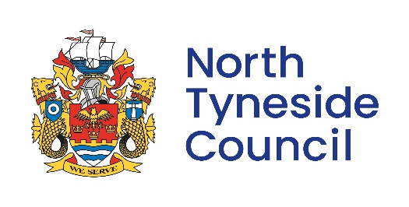  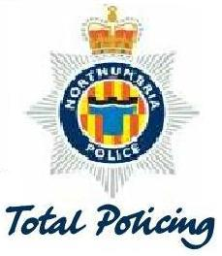 |  | Housing Services  North Tyneside Council  Community Protection Team  The Killingworth Site  Harvey Combe  Killingworth  Newcastle Upon Tyne  NE12 6UB  Date: 2nd June 2025
This matter is being dealt with by:
Community Protection Team
Tel: 0191 643 3333
Email:community.protection@northtyneside.gov.uk
Dear Parents & Carers
Reported Anti-Social behaviour - North Shields Football Ground

Unfortunately, North Tyneside Council have been informed by North Shields Football Club that they have seen an increase of Anti- Social behaviour including trespassing and damage to their buildings and grounds.

Trespassing, damage to property and deliberate fires are dangerous and are a criminal offence.
Deliberate fires waste time, money and take Tyne & Wear Fire crews away from real emergencies.
As the current warm spring and summer months approach us, deliberately starting fires on public grassland, parks and open spaces can quickly spread out of control.
Deliberate fire starting is arson and a criminal offence. It can also kill wildlife and cause widespread damage to the area. Members of the community are advised to be report immediately by calling 999, giving as much detail as possible so firefighters can get there as quickly as possible and prevent further damage.
Community Intelligence is very important, collaboratively we need to know who these individuals are so we can as a partnership speak to them around the dangers and impact this is having on the wider community.
If this matter does not refer to you than please disregard this letter.
Thank you for your assistance in this matter
Yours sincerely

Community Protection Team, North Tyneside Council

