Child-friendly Drug and Alcohol Policy

Date adopted: 03.02.25

Signed by Chair of Governors: D. Baldwin

Signed by Headteacher:K.Thompson

Date of review:February 2027

**Contents:**

Feeling safe and happy at school

1. What are the definitions of drugs, alcohol and smoking?
2. What to do if you feel pressured to smoke, take drugs or drink alcohol
3. The risks of smoking, taking drugs or drinking alcohol
4. Different types of drugs and their effects

1. Who to talk to

* **Feeling safe and happy at school**

At Percy Main Primary School, we want to make sure that you feel looked after, safe and happy when you are in and out of school.

This document, which is known as a “policy”, looks at what we do to make sure you are kept safe. We can help you by:

* Teaching you the definition of drugs.
* Teaching you what to do if you feel worried, scared or peer pressured into taking drugs.
* Making sure you know who you can speak to if you are worried.

If you don’t understand something or have any questions about what you read in the policy, please ask your teacher for help.

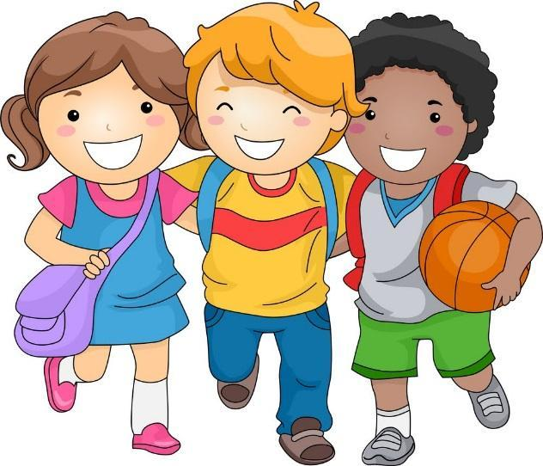

**What are the definitions of drugs, alcohol and smoking?**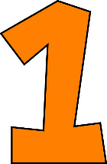

A drug is a chemical that you take into your body which changes the way you feel and act. Some drugs are prescribed by a doctor for illnesses and some drugs are illegal or unsafe. Drugs can take the form of many objects, including pills and drinks. They can also be taken in many ways, including being eaten, drank and smoked.

Alcohol is a substance that is in drinks like beer, wine and spirits. It is a substance that changes the way you feel by changing the way the brain sends and receives messages to the rest of the body. The brain controls thoughts, emotions, movements, and how you sense things. It is illegal for children under 18 to buy or consume alcohol.

Cigarettes contain nicotine and many cancer-causing chemicals that are harmful to both smokers and non-smokers. Smoking cigarettes can lead to addiction and cause many types of cancer. Similarly, electronic cigarettes are battery-powered devices that come in many forms. They contain liquids that users breathe in. They may contain nicotine, flavourings and a range of harmful chemicals. It is illegal for children under 18 to buy or use cigarettes and e-cigarettes.

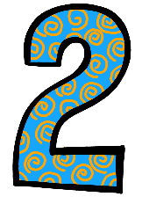

**What to do if you feel pressured to smoke, take drugs or drink alcohol**

It can be hard to say ‘no’ to your friends, especially if they’re taking drugs, smoking, or drinking alcohol. If they’re trying to get you to do something that you don’t want to do, this could make you feel scared and alone. You could try:

* Being assertive so you can say how you feel without being mean or pushy.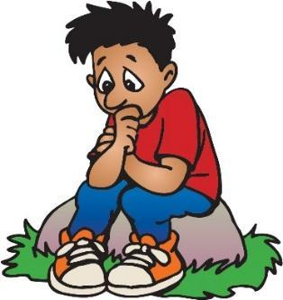
* Finding out more about peer pressure and how you can stop it.
* Talking to someone you trust or asking an adult for help.
* Thinking about what feels right for you and if these friends are your true friends.
* Talking to a counsellor for support.

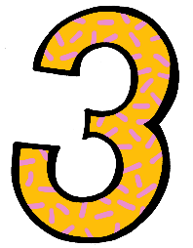

**The risks of smoking, taking drugs or drinking alcohol**

There are always risks involved when taking any kind of drug, smoking or drinking alcohol. Some substances can be unsafe and could make you very ill. Here are some of the risks:

* Damage to your physical and mental health
* Becoming addicted and feeling like you can’t cope without drugs or alcohol
* Falling behind with school work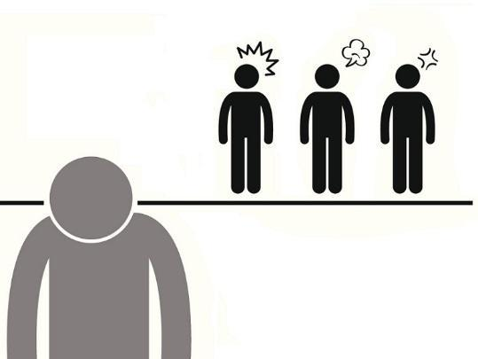
* Falling out with family and friends
* Getting into trouble with the police or involved in a crime
* Being more likely to do dangerous things
* Putting your health in danger by taking too much of a drug, known as 'overdosing’, or having a bad experience from what you’ve taken, also known as a ‘bad trip’
* Owing money to gangs or people who sell drugs who may become violent if you can’t pay

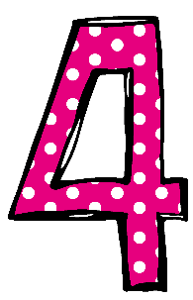

**Different types of drugs and their effects**

There are lots of different types of drugs and they can all be harmful. Illegal drugs are described in different classes including A, B and C, depending on how unsafe they are. 

The harmful effects of these include feeling paranoid, depressed, dizzy, anxious, out of control or physically ill. They can affect mental and physical health. You never know how your body will react, so while one person might be fine, another might end up with a reaction that could harm them.

By taking any type of illegal drug, you are also at risk of poisoning, overdosing or dying.

The punishment for taking, carrying, sharing or selling drugs depends on the type of drug. If the police caught you with any type of drug, you could be arrested and sent to prison.

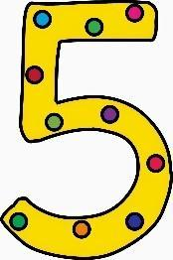

**Who to talk to**

If you have any concerns or worries, you can speak to your teacher, parent or another trusted adult. You will not be shouted at or punished if you have been involved with drugs or alcohol – as it’s important to speak up. 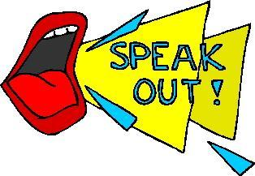

In every school, there is always somebody who has the responsibility to keep you safe and all staff have to tell that person if they are worried about you – this person is called the DSL, whichstands for **designated safeguarding lead**. Other members of staff have also been taught how to do the DSL’s job.

Staff are taught how to keep children safe as it is the most important part of their job. The list below shows the people at our school that can do the job of the DSL:

* Mrs Thompson
* Mrs Godfrey
* Mrs Leslie

There are also places outside of school that you can go to for help. You can call or visit:

* Childline on 0800 11 11 or visit [www.childline.org.uk](http://www.childline.org.uk)
* NSPCC on 0800 800 5000 or visit [www.nspcc.org.uk](http://www.nspcc.org.uk)
* Kidscape on 020 7730 3300 or visit [www.kidscape.org.uk](http://www.kidscape.org.uk)
* Youth Access on 020 8772 9900 or visit [www.youthaccess.org.uk](http://www.youthaccess.org.uk)