Music Long Term Plan 2025 2026
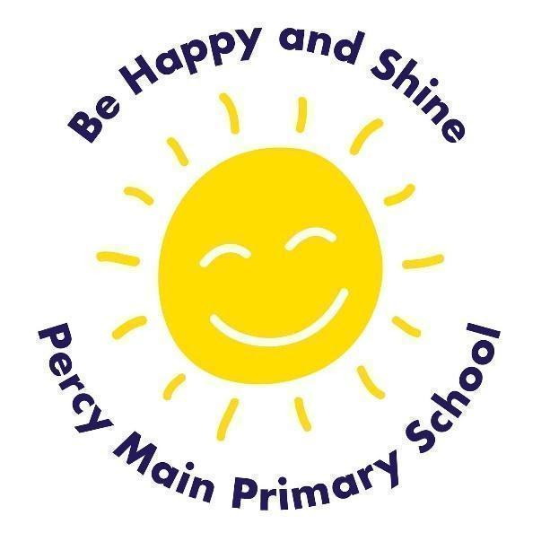
 | Autumn 1 | Autumn 2 | Spring1 | Spring2 | Summer1 | Summer2
Year One | Menu Song | Colonel Hathi’s March  Magical Musical Aquarium | Football | Down from Sea Interludes  Musical Conversations | Dancing and Drawing to Nautilus  Cat and Mouse | Come Dance with Me
Year Two | Tony Chestnut | Carnival of the Animals  Composing music inspired by birdsong | Grandma Rap | Orawa  Trains | Swing along with Shostakovich  Charlie Chaplin | Tanczymy Labada
Year Three | I’ve been to Harlem |  | Latin dance (Classroom percussion) |  | Fly with the stars (Classroom percussion)
Year Four | This little light of mine  The Pink Panther theme  Composing with colour/  Ukulele |  | The doot doot song  Fanfare for the common man  Spain |  | Global pentatonics  The horse in motion  Favourite song
Year Five | Ukelele 1 / What shall we do with the drunken sailor?* | Ukelele 2/ Why we sing / Introduction to songwriting | Madina tun nabi* | Building a groove/Época |  | Balinese gamelan/Composing in ternary form
Year Six | Happy | Classroom Jazz 2 | New Year Carol | You’ve got a friend |  | Music and Me

