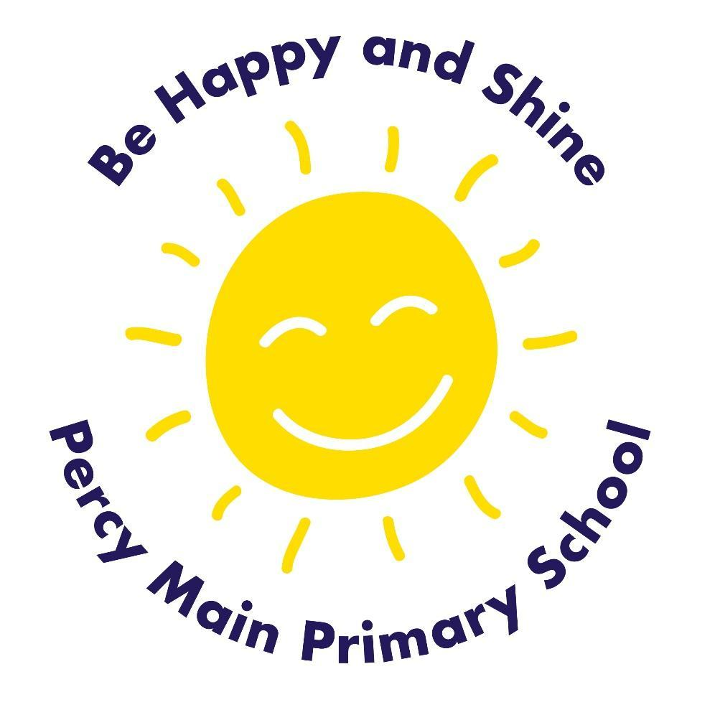
Reading Policy

Date adopted: 10th March 2025
Signed by Chair of Governors: Mr D Baldwin
Signed by Headteacher: Mrs K Thompson
Date of review: March 2026

Contents:
Statement of intent
- Legal framework
- Roles and responsibilities
- EYFS
- The curriculum
- Teaching and learning
- Assessment and reporting
- Resources
- Equal opportunities
- Additional reading activities
- Monitoring and reporting

Statement of intent
At Percy Main Primary School, we believe that being able to read well is a fundamental life skill for every child. Reading is at the heart of our curriculum and championed by our whole school community in order to inspire our pupils to develop a lifelong love of reading. We strive to create a reading culture in our school whereby children are immersed in reading opportunities, both for pleasure and to gain knowledge, which challenges and motivates them to read more. We use a variety of approaches to teach reading, seizing every opportunity to spark our children’s interest.

Our vision and aim is for every child to become a fluent and confident reader. We prioritise the teaching of reading skills, including the development of children’s phonetic skills, to ensure that every child learns to read as early as possible, providing the key to allow them full access to the wider curriculum.

Reading widely and often increases pupils’ vocabulary as they encounter words they would rarely hear or use in everyday speech. We intend to provide children with reading experiences that will lead to rich language development, so by the time children leave Percy Main they are empowered with a breadth of vocabulary that they can build on in their future prospects.

We believe that reading feeds the imagination and curiosity of our pupils, giving them access to worlds and experiences different to their own. We immerse our children in a vast range of reading materials and teach our children to be inquisitive readers who gain a thirst for exploring, discussing and questioning a range of genres. We want our children to value reading and have the confidence and knowledge to be able to discuss authors, styles and genres, and recognise the types of books they enjoy, sharing recommendations with their peers.

Legal framework
This policy has due regard to all relevant legislation and guidance including, but not limited to, the following:
- DfE (2014) ‘English programmes of study: key stages 1 and 2’
- DfE (2023) ‘Early years foundation stage statutory framework’
This policy operates in conjunction with the following school policies:
- Primary Teaching and Learning Policy
- Pupil Equality, Equity, Diversity and Inclusion Policy

Roles and responsibilities
The governing board will be responsible for:
- Ensuring a broad and balanced reading curriculum is implemented in the school.
- Ensuring the school’s reading curriculum is accessible to all pupils.
The headteacher will be responsible for:
- The overall implementation of this policy.
- Ensuring the school’s reading curriculum is implemented consistently.
- Ensuring appropriate resources are allocated to the reading curriculum.
- Ensuring all pupils are appropriately supported.
- Appointing a member of staff to lead on the school’s approach to teaching reading.
The literacy lead will be responsible for:
- Leading on the school’s approach to reading.
- Preparing curriculum plans and schemes of work for the subject.
- Communicating developments in the subject to all teaching staff and the SLT, as appropriate.
Teachers will be responsible for:
- Acting in accordance with this policy.
- Planning lessons effectively, ensuring a range of teaching methods are used to cover the content of the curriculum.
- Liaising with the literacy lead about key topics, resources and support for individual pupils.
- Monitoring the progress of pupils in their class and reporting this on an annual basis to parents.
- Reporting any concerns regarding the teaching of the subject to the subject leader or a member of the SLT.
- Undertaking any training that is necessary in order to effectively teach reading skills.
The SENCO will be responsible for:
- Liaising with the literacy lead in order to implement and develop specialist reading-based learning throughout the school.
- Organising and providing training for staff regarding the reading curriculum for pupils with SEND.
- Advising staff how best to support pupils’ needs.

EYFS
All pupils within the EYFS will be taught to develop their reading skills as an integral part of the topic work covered during the academic year.
All reading objectives will be underpinned by the early learning goals (ELGs) that pupils should have attained by the end of the EYFS.
In accordance with the word reading ELG, at the end of the EYFS, pupils at the expected level of development will be able to:
- Say a sound for each letter in the alphabet and at least 10 diagraphs.
- Read words consistent with their phonic knowledge by sound-blending.
- Read aloud simple sentences and books that are consistent with their phonic knowledge, including some common exception words.
In accordance with the comprehension ELG, at the end of the EYFS, pupils at the expected level of development will be able to:
- Demonstrate understanding of what has been read to them by retelling stories and narratives using their own words and recently introduced vocabulary.
- Anticipate, where appropriate, key events in stories.
- Use and understand recently introduced vocabulary during discussions about stories, non-fiction, rhymes and poems during role play.

The curriculum
Our English curriculum is derived around a sequence of high-quality age-appropriate texts. We use each book to create opportunities to develop key reading comprehension strategies and skills. Children learn a range of techniques which enables them to comprehend the meaning of what they read. The strategies which include inferring meaning from context, summarising or identifying key points and developing questioning strategies, will be taught in both Guided Reading and English lessons. Reading however, is not restricted to only these areas of the curriculum. In order for the children to expand their prior knowledge and vocabulary within each subject, it is important that they have access and are exposed to a range of texts, covering all areas of the curriculum.
In Year 1, pupils will be taught to:

Word reading
- Apply phonic knowledge and skills to decode words.
- Respond speedily with the correct sound to graphemes (letters or groups of letters) for all phonemes (40+), including, where applicable, alternative sounds for graphemes.
- Read accurately by blending sounds in unfamiliar words containing grapheme-phoneme correspondences (GPCs) that have been taught.
- Read common exception words, noting unusual correspondences between spelling and sound and where these occur in the word.
- Read words containing taught GPCs and -s, -es, -ing, -ed, -er, and -est endings.
- Read other words of more than one syllable that contain taught GPCs.
- Read words with contractions, e.g. I’m, I’ll, we’ll, and understand that the apostrophe represents the omitted letter/s.
- Accurately read books aloud that are consistent with their developing phonic knowledge and that do not require them to use other strategies to work out words.
- Re-read these books to build up their fluency and confidence in reading.

Comprehension
- Develop pleasure in reading, motivation to read, vocabulary and understanding by:
  - Listening to and discussing a wide range of poems, stories and non-fiction at a level beyond which they can read independently at.
  - Being encouraged to link what they read or hear to their own experiences.
  - Becoming very familiar with key stories, fairy stories and traditional tales, retelling them and considering their particular characteristics.
  - Recognising and joining in with predictable phrases.
  - Learning to appreciate rhymes and poems, and to recite some by heart.
  - Discussing word meanings, linking new meanings to those already known.
- Understand the books they can already read accurately and fluently, and those they listen to by:
  - Drawing on what they already know or on background information and vocabulary provided by the teacher.
  - Checking that the text makes sense to them as they read.
  - Correcting inaccurate reading.
  - Discussing the significance of the title and events.
  - Making inferences on the basis of what is being said and done.
  - Predicting what might happen on the basis of what has been read so far.
- Participate in discussion about what is read to them, taking turns and listening to what others say.
- Explain clearly their understanding of what is read to them.
In Year 2, pupils will be taught to:

Word reading
- Continue to apply phonic knowledge and skills to decode words until automatic decoding has become embedded and reading is fluent.
- Read accurately by blending the sounds in words that contain the graphemes taught so far, especially recognising alternative sounds for graphemes.
- Accurately read words of two or more syllables that contain the graphemes taught so far.
- Read words containing common suffixes.
- Read further common exception words, noting unusual correspondences between spelling and sound and where these occur in the word.
- Read most words quickly and accurately, without overt sounding and blending, when they have been frequently encountered.
- Read aloud books closely matched to their improving phonic knowledge, sounding out unfamiliar words accurately, automatically and without undue hesitation.
- Re-read these books to build up their fluency and confidence in word reading.

Comprehension
- Develop pleasure in reading, motivation to read, vocabulary and understanding by:
  - Listening to, discussing and expressing views about a wide range of contemporary and classic poetry, stories and non-fiction at a level beyond that at which they can read independently.
  - Discussing the sequence of events in books and how items of information are related.
  - Becoming increasingly familiar with and retelling a wide range of stories, fairy stories and traditional tales.
  - Being introduced to non-fiction books that are structured in different ways.
  - Recognising simple recurring literary language in stories and poetry.
  - Discussing and clarifying the meanings of words, linking new meanings to known vocabulary.
  - Discussing their favourite words and phrases.
  - Continuing to build up a repertoire of poems learnt by heart, appreciating these and reciting some, with appropriate intonation to make the meaning clear.
- Understand the books that they can already read accurately and fluently, and those that they listen to by:
  - Drawing on what they already know or on background information and vocabulary provided by the teacher.
  - Checking that the text makes sense to them as they read, and correcting inaccurate reading.
  - Making inferences on the basis of what is being said and done.
  - Answering and asking questions.
  - Predicting what might happen on the basis of what has been read so far.
- Participate in discussion about books, poems and other works that are read to them and those that they can read for themselves, taking turns and listening to what others say.
- Explain and discuss their understanding of books, poems and other material, both those that they listen to and those that they read for themselves.
In Years 3 and 4, pupils will be taught to:

Word reading
- Apply their growing knowledge of root words, prefixes and suffixes (etymology and morphology) to reading aloud and understanding the meaning of new words they meet.
- Read further exception words, noting the unusual correspondences between spelling and sound, and where these occur in the word.

Comprehension
- Develop positive attitudes to reading, and an understanding of what they read, by:
  - Listening to and discussing a wide range of fiction, poetry, plays, non-fiction and reference books or textbooks.
  - Reading books that are structured in different ways and reading for a range of purposes.
  - Using dictionaries to check the meaning of words that they have read.
  - Increasing their familiarity with a wide range of books, including fairy stories, myths and legends, and retelling some of these orally.
  - Identifying themes and conventions in a wide range of books.
  - Preparing poems and play scripts to read aloud and to perform, showing understanding through intonation, tone, volume and action.
  - Discussing words and phrases that capture the reader’s interest and imagination.
  - Recognising some different forms of poetry, e.g. free verse, narrative poetry.
- Understand what they read, in books they can read independently, by:
  - Checking that the text makes sense to them, discussing their understanding, and explaining the meaning of words in context.
  - Asking questions to improve their understanding of a text.
  - Drawing inferences such as inferring characters’ feelings, thoughts and motives from their actions, and justifying inferences with evidence.
  - Predicting what might happen from details stated and implied.
  - Identifying main ideas drawn from more than one paragraph and summarising these.
  - Identifying how language, structure, and presentation contribute to meaning.
- Retrieve and record information from non-fiction.
- Participate in discussion about both books that are read to them and those they can read for themselves, taking turns and listening to what others say.
In Years 5 and 6, pupils will be taught to:

Word reading
- Apply their growing knowledge of root words, prefixes and suffixes (morphology and etymology) to both read aloud and understand the meaning of new words they encounter.

Comprehension
- Maintain positive attitudes to reading and an understanding of what they read by:
  - Continuing to read and discuss an increasingly wide range of fiction, poetry, plays, non-fiction and reference books or textbooks.
  - Reading books that are structured in different ways and reading for a range of purposes.
  - Increasing their familiarity with a wide range of books, including myths, legends and traditional stories, modern fiction, fiction from our literary heritage, and books from other cultures and traditions.
  - Recommending books that they have read to their peers, giving reasons for their choices.
  - Identifying and discussing themes and conventions in and across a wide range of writing.
  - Making comparisons within and across books.
  - Learning a wider range of poetry by heart.
  - Preparing poems and plays to read aloud and to perform, showing understanding through intonation, tone and volume so that the meaning is clear to an audience.
- Understand what they read by:
  - Checking that the book makes sense to them, discussing their understanding and exploring the meaning of words in context.
  - Asking questions to improve their understanding.
  - Drawing inferences such as inferring characters’ feelings, thoughts and motives from their actions, and justifying inferences with evidence.
  - Predicting what might happen from details stated and implied.
  - Summarising the main ideas drawn from more than one paragraph, identifying key details that support the main ideas.
  - Identifying how language, structure and presentation contribute to meaning.
- Discuss and evaluate how authors use language, including figurative language, considering the impact on the reader.
- Distinguish between statements of fact and opinion.
- Retrieve, record and present information from non-fiction.
- Participate in discussions about books that are read to them and those they can read for themselves, building on their own and others’ ideas and challenging views courteously.
- Explain and discuss their understanding of what they have read, including through formal presentations and debates, maintaining a focus on the topic and using notes where necessary.
- Provide reasoned justifications for their views.

Teaching and learning
The reading curriculum will be delivered in line with the school’s Primary Teaching and Learning Policy.
The teaching of reading will primarily be delivered during literacy lessons; however, reading will be encouraged in all areas of the curriculum and other learning activities.
The statutory national curriculum content from the DfE’s ‘English programmes of study: key stages 1 and 2’, as outlined above, will be used as the starting point for lesson planning.
Lesson plans will balance visual, auditory and kinaesthetic elements used in teaching, ensuring that all pupils with different learning styles can access the learning experience.
Reading will be taught both as a discrete lesson and as part of cross-curricular themes when appropriate.
Phonics – Read Write Inc

We prioritise the teaching of phonics from Reception and opportunities for early reading throughout the early years, in order to provide all children with a solid foundation for learning.

We use RWI as our phonics scheme to teach phonics. This is a systematic, fast-paced approach ensuring coverage and progression. Children are given time to practise and consolidate their growing knowledge. Within daily RWI storybook sessions, children are encouraged and supported to not only develop their decoding skills but also their comprehension and fluency.

The RWI programme is designed for:
• Pupils in Year R to Year 2 who are learning to read and write
• Any pupils in Years 2 and KS2 who need to catch up rapidly In Read Write Inc.
Pupils who require support in order to:
• Decode letter-sound correspondences quickly and effortlessly, using their
phonic knowledge and skills
• Read common exception words on sight
• Understand what they read
• Read aloud with fluency and expression
• Write confidently, with a strong focus on vocabulary and grammar
• Spell quickly and easily by segmenting the sounds in words
• Acquire good handwriting.

In addition, we teach pupils to work effectively with a partner to explain and consolidate what they are learning. This provides the teacher with opportunities to assess learning and to pick up on difficulties, such as pupils’ poor articulation, or problems with blending or alphabetic code knowledge.

In Reception we emphasise the alphabetic code. The pupils rapidly learn sounds and the letter or groups of letters they need to represent them. Simple mnemonics help them to grasp this quickly. This is especially useful for pupils at risk of making slower progress. When grouping the children we do this homogeneously, according to their progress in reading rather than their writing, as for some children their progress in writing can be lower than that of their reading ability.

Pupils have daily practice of reading high frequency words with irregular spellings – common exception words. We make sure that pupils are provided with individual reading books that are matched to their increasing knowledge of phonics and the common exception words. This is so that, early on, they experience success and gain confidence that they are readers. Re-reading and discussing these books with the teacher throughout the week, supports their increasingly fluent decoding. Alongside this, the teachers read a wide range of stories, poetry and non-fiction to pupils.

Embedding the alphabetic code early on means that pupils quickly learn to write simple words and sentences. We encourage them to compose each sentence aloud until they are confident to write independently. Pupils write at the level of their spelling knowledge. The quality of the vocabulary they use in their writing reflects the language they have heard in the books the teacher has read to them; they have also discussed what the words mean.

Guided Reading

Our aim is for pupils to complete the phonics programme by the end of KS1. Once children complete RWI, they are taught in their year group using a range of high-quality reading resources, including classical texts. Guided reading sessions integrate reading, writing, thinking, and the use of Oracy in all activities, to ensure the daily development of children’s comprehension and wider literacy skills.

Pupils are encouraged to take their own meaning from each text, becoming independent and critical thinkers. Comprehension activities are designed to help children to infer, summarise, question, clarify, predict and argue a point of view. The children also make connections between texts and their own experiences

Fluency

Fluent reading supports reading comprehension and therefore is an integral part of the teaching of reading in our school. When a child completes the RWI programme they are encouraged to develop their fluency skills through focused and progressive activities. Through these activities children learn how to read accurately, with automaticity and prosody. In order for the children to become fluent readers, the teaching of fluency starts daily in the Early Years and continues through to the end of Key Stage 2.

Key focus for teaching fluency
The children are provided with a range of opportunities to practice and develop their fluency skills across the curriculum and on a daily basis.
Focus | Opportunities
Early Years
- Development of Auditory and Communication and language skills  - Word recognition – Read Write Inc  - Modelling prosody  - Choral recital of repeated refrains in a story  - Singing  - Use of poetry and rhyme | - Adult interactions within provision including modelling and extending children’s language during interactions  - Planning – focus upon identifying vocabulary that will be explicitly taught  - Keyworker groups / small group time with a focus upon developing social awareness, relationships and problem solving.  - Storytelling opportunities – adult and child led  - Storytime using books with repeated refrains that the children will be encouraged to join with  - Rhyming games and stories (inc the use of poetry)  - RWI sessions  - 3pm Daily read – whole class  - Shared reading as part of a small group  - 1:1 reading inc opportunities to re read familiar books.  - Poetry Basket  - Listening walks  - Helicopter Stories
Key Stage 1
- Continued development of Auditory and Communication and language skills for identified children using both teacher assessment and Launchpad for Literacy gaps.  - Daily word recognition – Read Write Inc sessions  - Opportunities for repeated reading aloud – children to develop their use of prosody when reading familiar text / phrase.  - Repeated reading  - Self correction  - Choral reading with a focus upon explicitly improving children’s prosody.  - Use of poetry and rhyme | - Opportunities for adult interactions within the classroom including modelling and extending children’s language.  - Planning – focus upon identifying vocabulary that will be explicitly taught  - Shared Reading – guided reading  - 3pm daily read – whole class  - Shared reading as part of a small group  - Shared reading opportunities  - 1:1 reading with adult  - 1:1 Interventions – RWI  - Year group recommended booklist for the children to access matching pitch and interest for children to read fluently.  - Review and restock of the quality of books in the book area  - Guided reading opportunities  - CW daily phonics session for children who have finished the programme
Key Stage 2
- Opportunities for children to re-read a text several times prior to a performance or small group work.  - Readers Theatre  - Model strategies such as exploration of morphology or etymology to read unfamiliar words with accuracy and find opportunities for repeated reading to build automaticity  - Echo reading  - Choral reading  - Use of poetry and rhyme | - Opportunities for children to sing songs and perform poetry.  - Role play using scripts and monologues  - Planning – focus upon identifying vocabulary that will be explicitly taught  - Shared Reading – guided reading  - 3pm daily read – whole class  - Shared reading as part of a small group  - Shared reading opportunities  - Year group recommended booklist for the children to access matching pitch and interest for children to read fluently.  - Review and restock of the quality of books in the book area  - Guided reading opportunities  - Provide, where possible children with their own copy of the texts to follow, re read, rehearse and perform.

Reading Books

All children work through the RWI books at the appropriate level matched to their phonological skill level. This starts at learning the speed sounds in set 1,2 and 3, moving through oral blending and blending sounds in words, to then accessing story books at the correct level from Ditties to Grey. Suitable books to choose from are available in each year group and are monitored by the English coordinator, RWI group lead and the class teachers (this may not be the child’s RWI teacher).

Each week every child takes home a RWI book appropriate to the level they read independently and they access in their phonics group. If a child does not access a RWI book, they may take home individual sounds to use in order to practice their blending and to help them learn the skills to access a RWI levelled text. Children who are at the early stage of reading (ie in RWI) may also take a picture book home to share with their family to extend their vocabulary and to further promote the love of reading. Each family is encouraged to read the same story few times throughout the week to develop understanding of the text.

Once children have completed the Read Write Inc scheme and can read with increased confidence and fluency, they will access texts from the Book Bug scheme (KS1), Tree Top scheme (throughout KS2) and their individual class library.
Throughout the week children will be provided with an opportunity to read to an adult. Each child will read a minimum of once per week, this will differ in line with each individual need ranging from daily to 3x per week. In addition to this the children are provided with daily independent reading time in their classrooms.

Reading for Pleasure and Book Club

All children are provided with an opportunity to read for pleasure each day and will share a story with their teacher at 3pm every afternoon. Children can access their class library, online stories, class novels or a book from home. Class libraries are equipped with a range of fiction and non-fiction titles. Care is taken to ensure that a wide range of texts are available in terms of content, form and genre, e.g. texts which are accessible and challenging, texts which show cultural diversity and avoid stereotyping of race, gender and class. The learning environments promote reading in an engaging way. There is an abundance of vocabulary for the children to access. Throughout the learning areas within school, the classrooms have displays with graphemes to support the teaching of phonics.

Book Club

Book Club takes place weekly and is an engaging and interactive way to encourage the children to develop a love for reading. It involves choosing age-appropriate books, or using the class text, to evoke discussions, encourage questioning and provide an opportunity for the children to make predictions about the book they are reading. Book Club takes place for 30 mins at the end of every week.

Assessment and reporting
Pupils’ reading ability will be assessed every half term.
The EYFS Profile will be completed for each pupil in the final term of the year in which they reach age five. The progress and development of pupils within the EYFS is assessed against the ELGs outlined in the ‘Statutory framework for the early years foundation stage’.
Formative and summative assessments will take place throughout the year to assess pupils’ progress and attainment in reading and to identify support required. Pupils’ reading will also be assessed during the relevant statutory assessments.
Assessment will take various forms, including the following:
- Talking to pupils and asking questions
- Discussing pupils’ work with them
- Marking work against learning objectives
- Observing oral and performative tasks and activities
- Classroom tests and formal exams
- BRP assessment
- RWI assessment
- Benchmark Reading Assessment
- 1:1 Reading
Parents will be provided with a written report about their child’s progress during the summer term every year. These will include information on pupils’ attitudes towards reading and understanding of the key concepts.
Verbal reports will be provided at parent-teacher interviews during the autumn and spring terms.
The progress of pupils with SEND will be monitored by the SENCO.

Resources
The literacy lead will be responsible for the management and maintenance of reading resources, as well as for liaising with the SBM to purchase further resources.
Reading resources will be stored in each classroom.
All children are provided with an opportunity to read for pleasure each day. Children can access their class library, online stories, class novels or a book from home. Class libraries are equipped with a range of fiction and non-fiction titles. Care is taken to ensure that a wide range of texts are available in terms of content, form and genre, e.g. texts which are accessible and challenging, texts which show cultural diversity and avoid stereotyping of race, gender and class.

Equal opportunities
The school will ensure that all pupils have equal access to the reading curriculum, in line with the Pupil Equality, Equity, Diversity and Inclusion Policy.
The school will actively encourage all pupils to read books that are suitable for their reading ability, and this will be reflected in the reading materials which are used.
The literacy lead and teachers will ensure reading activities are adapted as appropriate to ensure all pupils can access the curriculum.

Additional reading activities
Alongside the set reading curriculum, the school ensures pupils are able to take part in a range of other reading activities, including the following:
- Visits to local libraries
- Celebration of reading-based awareness days, such as World Book Day
- Shared reading during breaktimes with school Reading Buddies

Reading at home
Parental involvement and encouragement play a crucial part in pupils’ reading development and the school will promote a home-school reading partnership by:
- Communicating with parents and sharing information with them through parent meetings, newsletters, text messages, social media, and curriculum evenings.
- Giving pupils a book to read at home each day to further the skills they have learned during guided reading.
- Encouraging parents to make notes in the pupils’ diaries about reading progress made at home.
Monitoring and review
This policy will be reviewed on an annual basis by the literacy lead and the headteacher.
Any changes made to this policy will be communicated to all teaching staff and other key stakeholders.
The next scheduled review of this policy is March 2026

